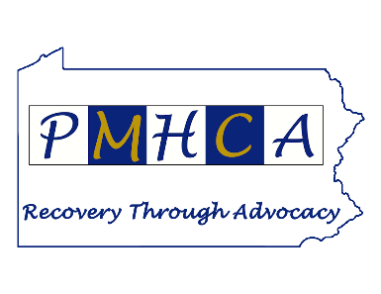
2020 PMHCA’s Rockin’ Your Recovery Event
October 4 – 10, 2020

October 4 – 10 is Mental Illness Awareness Week. In honor of this, PMHCA will be offering a week of virtual events celebrating the recovery journey of those dealing with mental illness. We hope you will help support our work!

Sponsorship Packages

Gold Level Sponsor – $500
- Sponsor logo in PMHCA VISION newsletter
- 1/2 page ad in PMHCA VISION newsletter
- Sponsor logo on PMHCA website with link to your homepage
- Pre-record a 2-3 minute publicity video about sponsor company/association that will be played at each event (6 days)

Silver Level Sponsor – $250
- Sponsor logo in PMHCA VISION newsletter
- 1/4 page ad in PMHCA VISION newsletter
- Sponsor logo on PMHCA website with link to your homepage
- Sponsor recognition at each event (6 days)

Bronze Level Sponsor - $100
- Sponsor logo in PMHCA VISION newsletter
- Sponsor logo on PMHCA website with link to your homepage

Scan this Code to Register Online

Sponsorship Information:

Sponsor level __________________________________________________________________

Organization: __________________________________________________________________

Contact Name: _________________________________________________________________

Address: ______________________________________________________________________

City/State/Zip: _________________________________________________________________

Email Address: _________________________________________________________________

Phone Number: ________________________________________________________________

Please send form and payment to:
PMHCA
4105 Derry Street
Harrisburg, PA 17111
Attention: Tyler Eppley
(Make checks payable to PMHCA)

Please submit logo or advertising information to Anthony Pascarella at anthony@pmhca.org

All information must be received by September 25, 2020.

Thank you for your support!

